Using S3 service from AWS

Select s3 service AWS after logging in

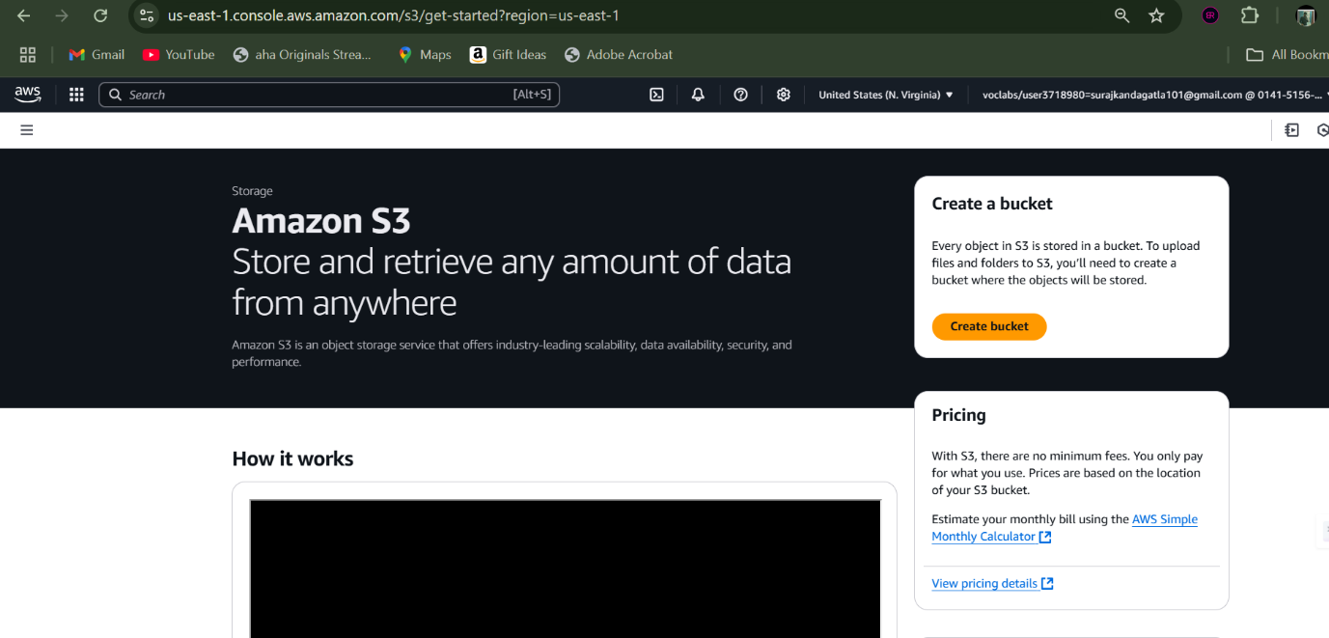

Select option named create bucket and provide a global-unique name to it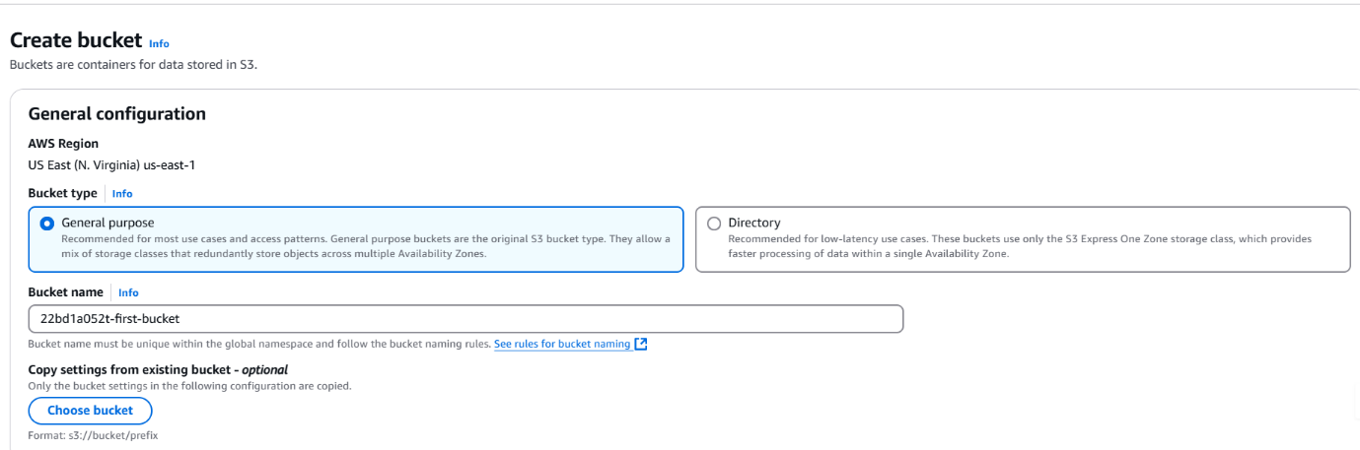

Ensure ACL is disabled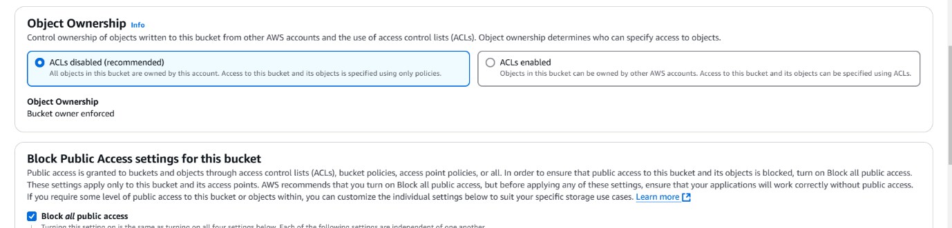

Then click create bucket to create it.

Now our bucket is ready.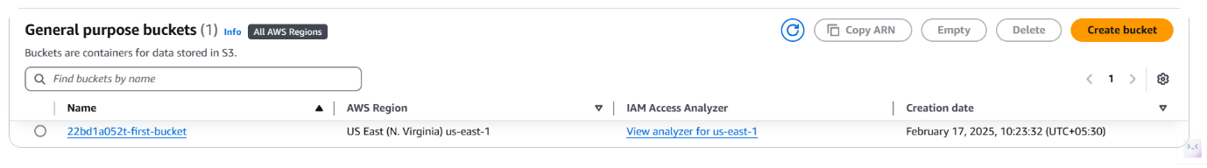

Select our bucket and upload files accordingly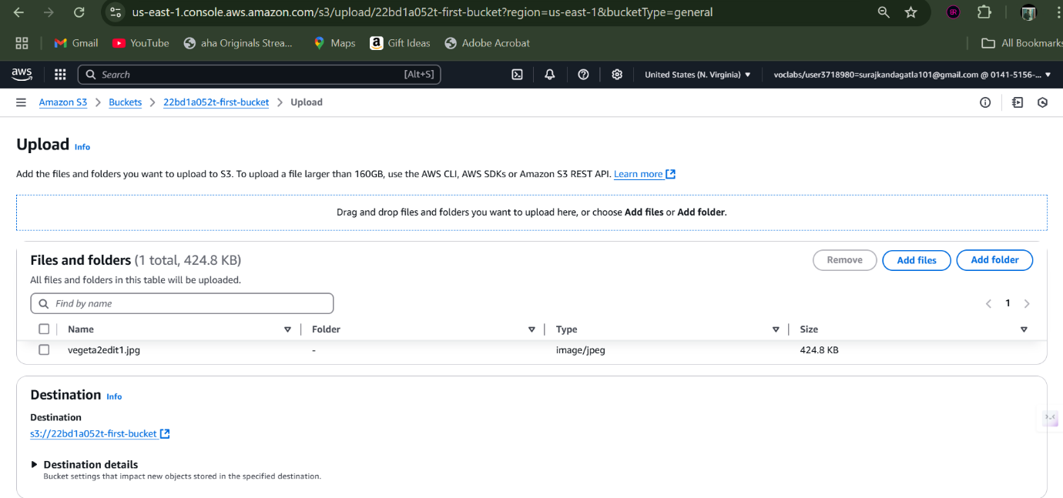

Now try to access the bucket object using its object URL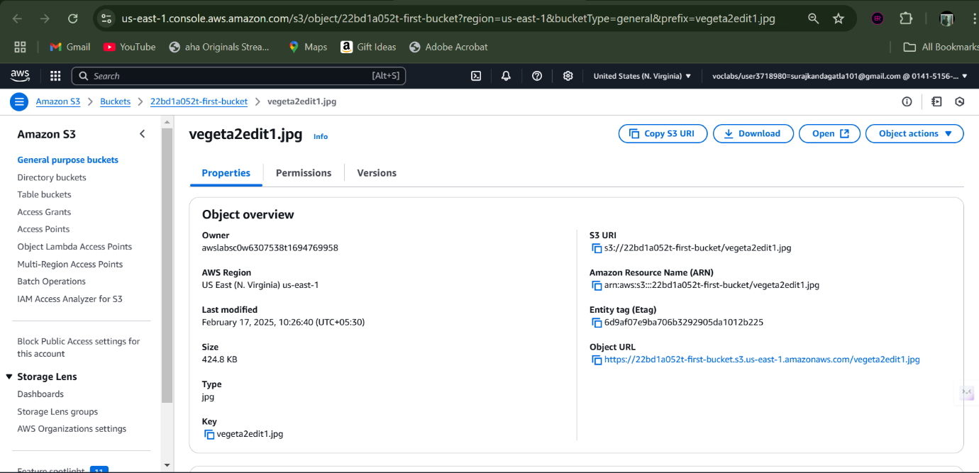

We can’t access it as we have disabled it’s access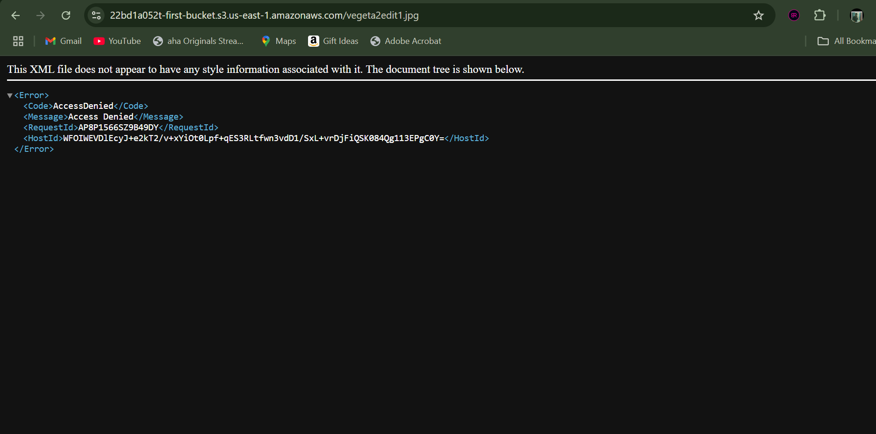

Now head to permissions section of our bucket and edit bucket public access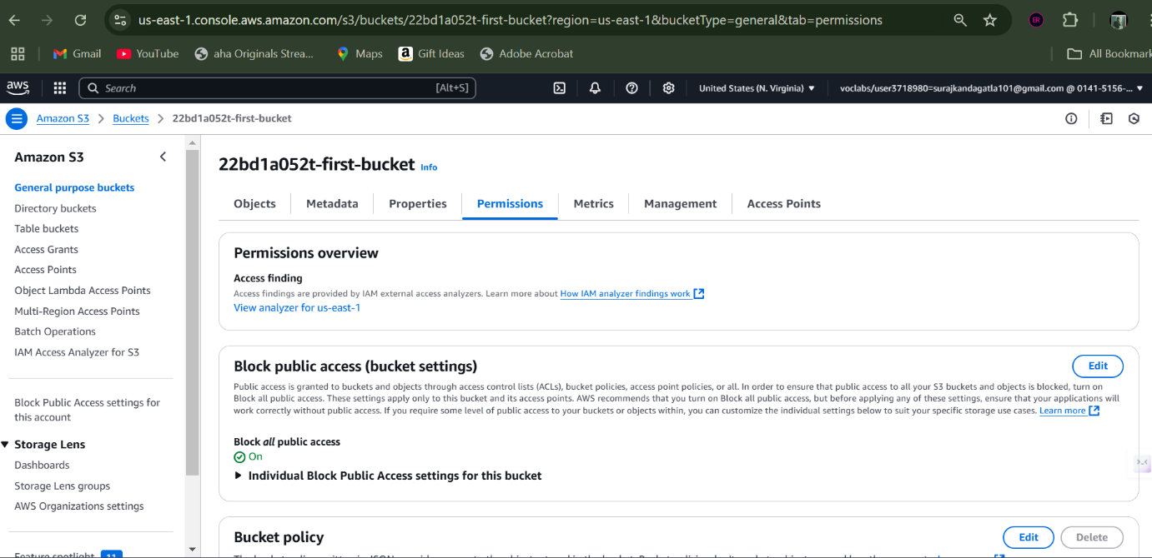

Now enable public access by removing the restriction and save the changes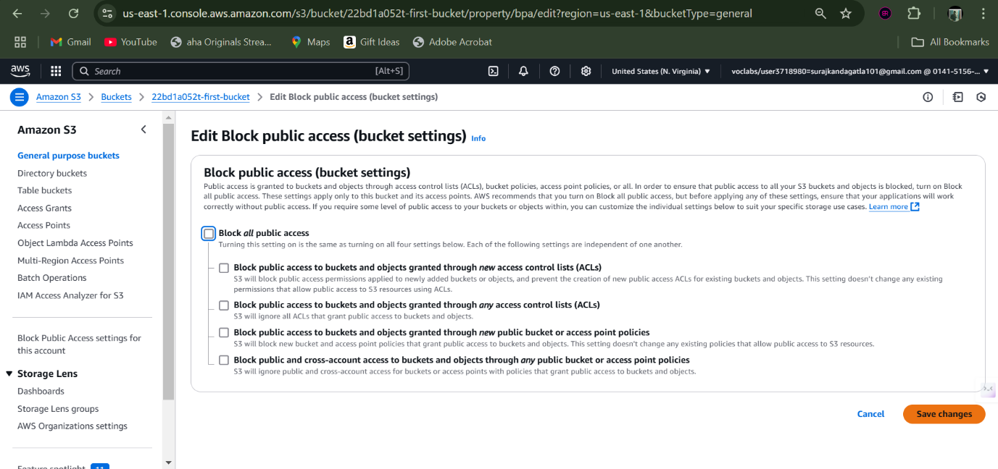

Now navigate to object ownership and click edit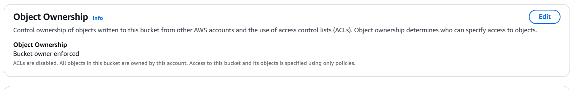

Enable ACL and save the changes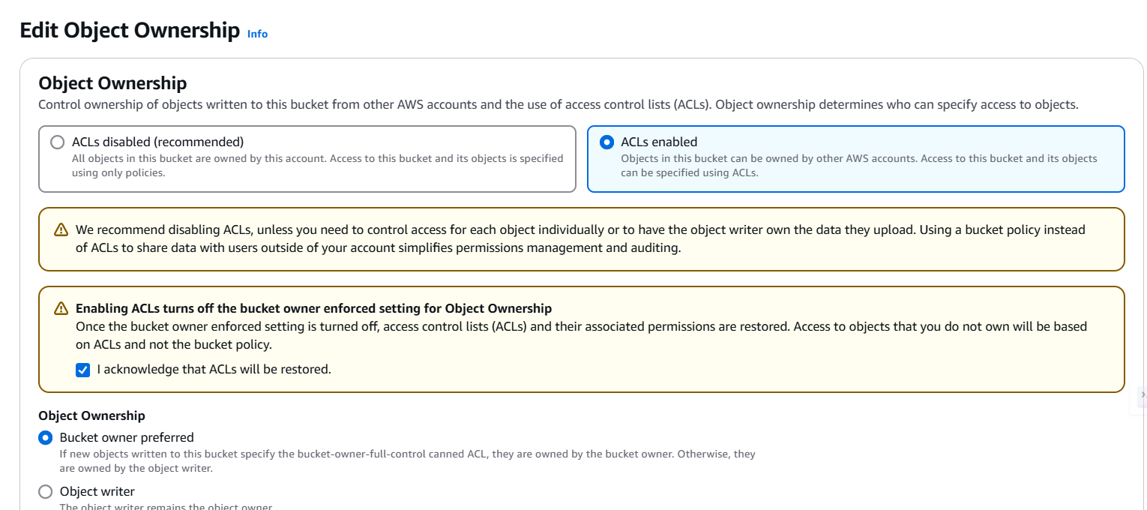

Now navigate to ACL section and edit it.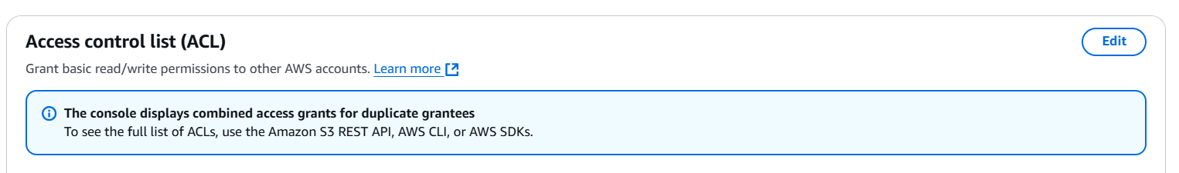

Allow public access i.e Everyone access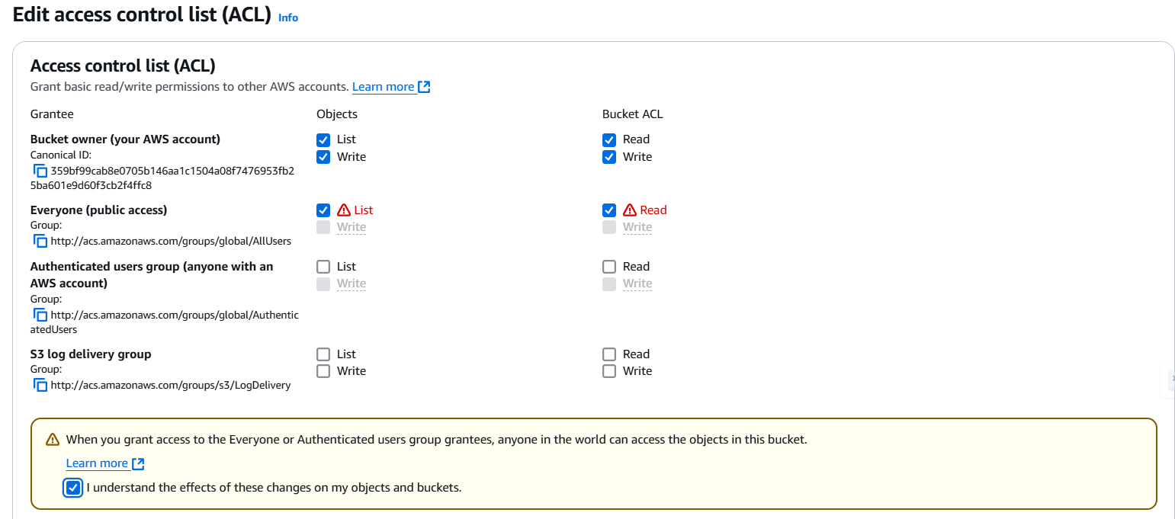

Now navigate to the object in out bucket and head to its permissions 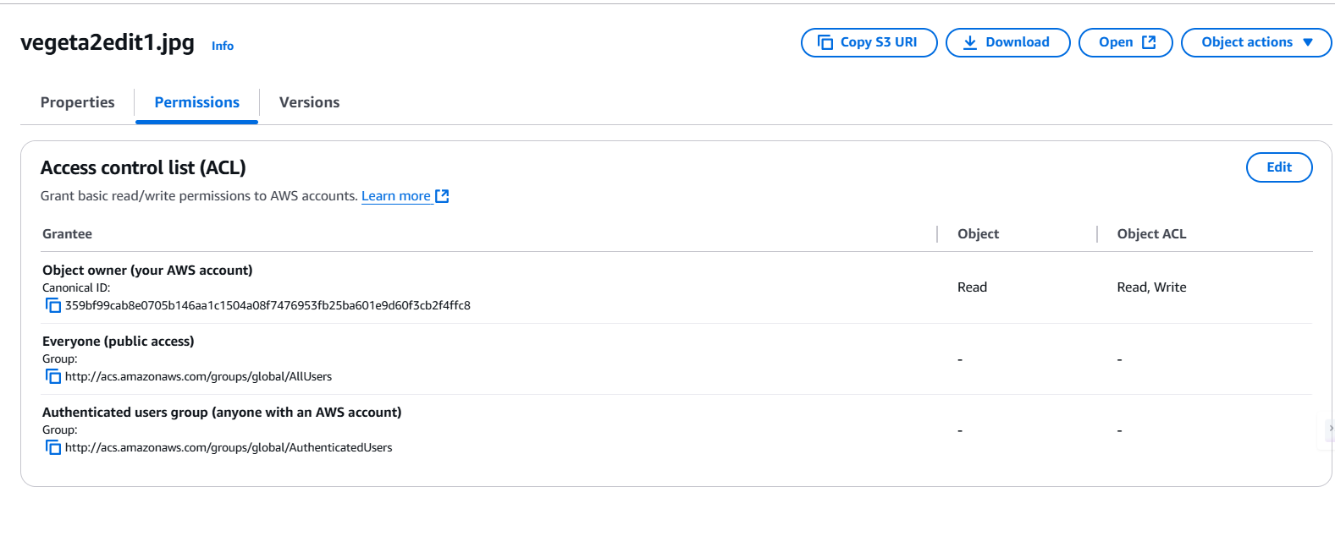

Now provide public access to your object.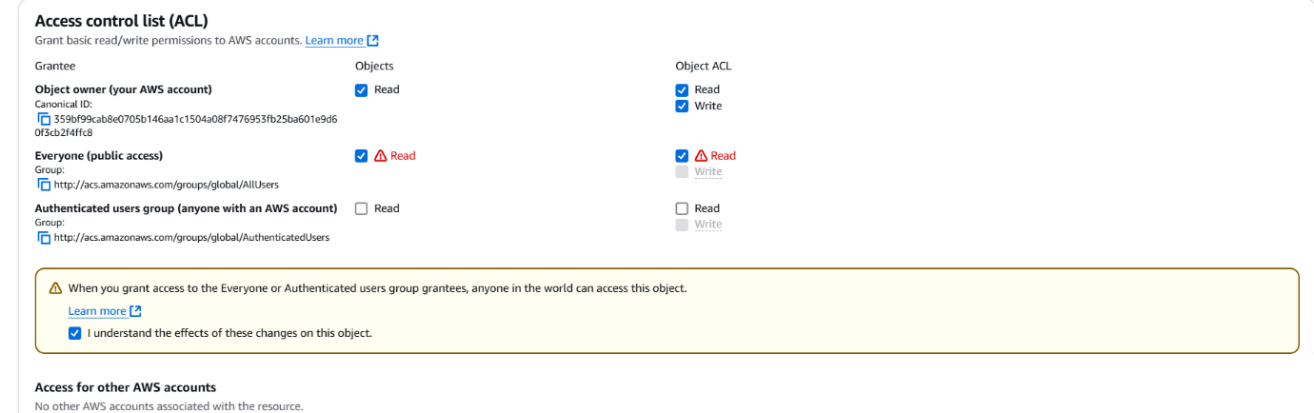

Now everyone can access our object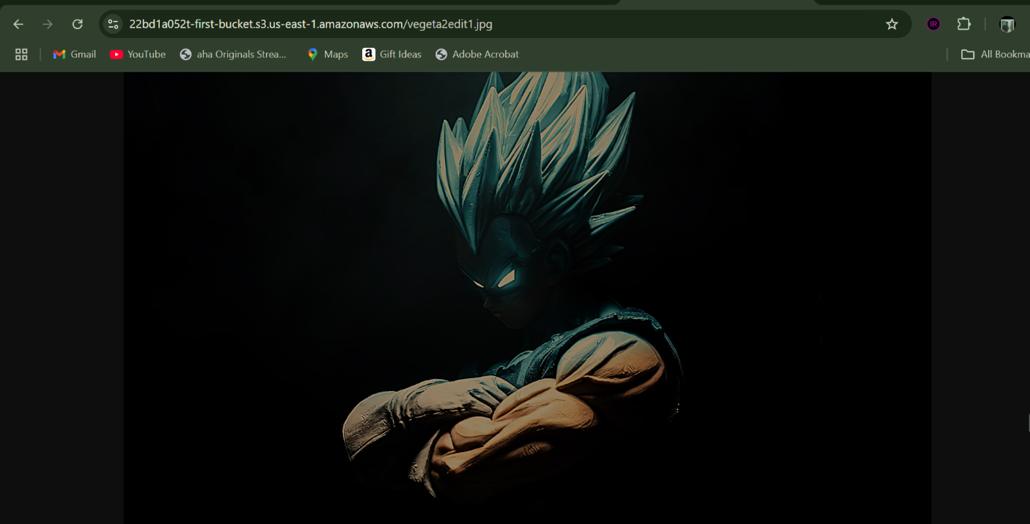

Bucket object url: https://22bd1a052t-first-bucket.s3.us-east-1.amazonaws.com/vegeta2edit1.jpg